Assignment 1
Ameya Konkar UID: 118191058

Q1. Assume that you have a camera with a resolution of 5MP where the camera sensor is square shaped with a width of 14mm. It is also given that the focal length of the camera is 25mm.
1. Compute the Field of View of the camera in the horizontal and vertical direction.

d = 14mm
f = 25 mm
By computing we find = 15.64
As the camera sensor is square shapped, the FoV in horizontal and vertical direction is the same.

2. Assuming you are detecting a square shaped object with width 5cm, placed at a distance of 20 meters from the camera, compute the minimum number of pixels that the object will occupy in the image.

Object distance from the camera = 20 m = 20000 mm
= 15.64
By using similarity of triangle,
=
By computing we get,
Unknown(x) = 5593 mm
Therefore, total FoV = = mm
The camera has 5MP. The total FoV corresponds to 5MP
=

Therefore, y = 99.89 pixels.

Q2. A ball is thrown against a white background and a camera sensor is used to track its trajectory. We have a near perfect sensor tracking the ball in video1 and the second sensor is faulty and tracks the ball as shown in video2. Clearly, there is no noise added to the first video whereas there is significant noise in the second video. Assuming that the trajectory of the ball follows the equation of a parabola:
1. Use Standard Least Squares to fit curves to the given videos in each case. You have to plot the data and your best fit curve for each case. Submit your code along with the instructions to run it.
(Hint: Read the video frame by frame using OpenCV’s inbuilt function. For each frame, filter the red channel for the ball and detect the topmost and bottom most colored pixel and store it as X and Y coordinates. Use this information to plot curves.)
Used the same steps for both the parts of the question.
- Did Convert the image into a binary image by masking it. Thus converting the red pixels of the ball into white color and the rest pixels into black color.
- Used the find contours method to find the area of the area of the ball (white pixels). Thus finding the pixel coordinates and getting the extreme top and bottom coordinates of the ball.
- Merged the top and bottom coordinates in a single list.
- Segregated the list in two lists of x and y coordinates.
- Created a X matrix which consists of the features [1 X X²] and Y matrix [Y]
- Used Normal equation to find a, b, c (from y = ax² + bx + c)
- Used np.linspace to create a x list so the corresponding ans using the found parameters can be found.
- Did plot x and ans in matplotlib.

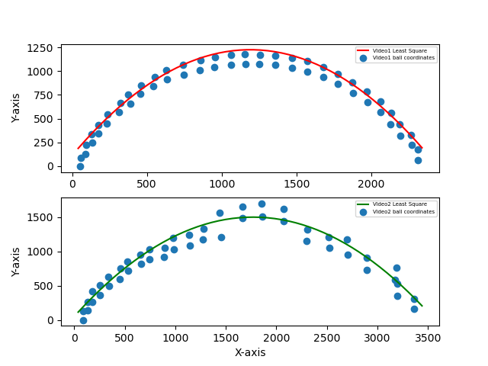
Q3. In the above problem, we used the least squares method to fit a curve. However, if the data is scattered, this might not be the best choice for curve fitting. In this problem, you are given data for health insurance costs based on the person’s age. There are other fields as well, but you have to fit a line only for age and insurance cost data. The data is given in .csv file format and can be downloaded from here.
1. Compute the covariance matrix (from scratch) and find its eigenvalues and eigenvectors. Plot the eigenvectors on the same graph as the data. Refer to this article for better understanding. [10]
- Calculated the variance for X and Y matrices.
- Calculated the covariance using X and Y matrices.
- Created a covariance matrix using the parameters.
- Computed the eigenvalues and eigenvectors for the matrix.

Covariance Matrix

Eigen Vaues and Eigen Vectors of the Covariance matrix
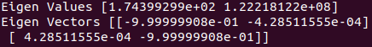

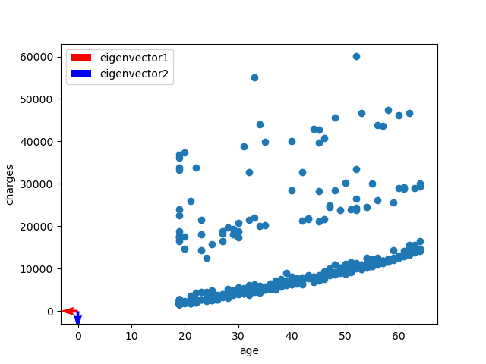

2. Fit a line to the data using linear least square method, total least square method and RANSAC. Plot the result for each method and explain drawbacks/advantages for each. [15]

- Least squares method
Advantages: The statistical method reveals information about cost structures and distinguishes between different variables’ roles in affecting output. Coefficients can be interpreted in terms of cost drivers or how inputs contribute to output.
Disadvantages: Large data set is necessary in order to obtain reliable results. The regression results are sensitive to functional form if the error term is not adequately interpreted, which can lead to widely varying conclusions, depending on how the regression is initially set up.
- Total Least Square method
Advantages: If the functional model and the stochastic model have a certain structure, the solution can be obtained via singular value decomposition (SVD) or an eigenvalue problem.
Such solutions are direct solutions and thus no starting values are needed.
Disadvantages: Total least squares does not have the property of units-invariance. i.e. it is not scale invariant.
- RANSAC
Advantages: An advantage of RANSAC is its ability to do robust estimation of the model parameters, i.e., it can estimate the parameters with a high degree of accuracy even when a significant number of outliers are present in the data set.
Disadvantages: A disadvantage of RANSAC is that there is no upper bound on the time it takes to compute these parameters. When the number of iterations computed is limited the solution obtained may not be optimal, and it may not even be one that fits the data in a good way.
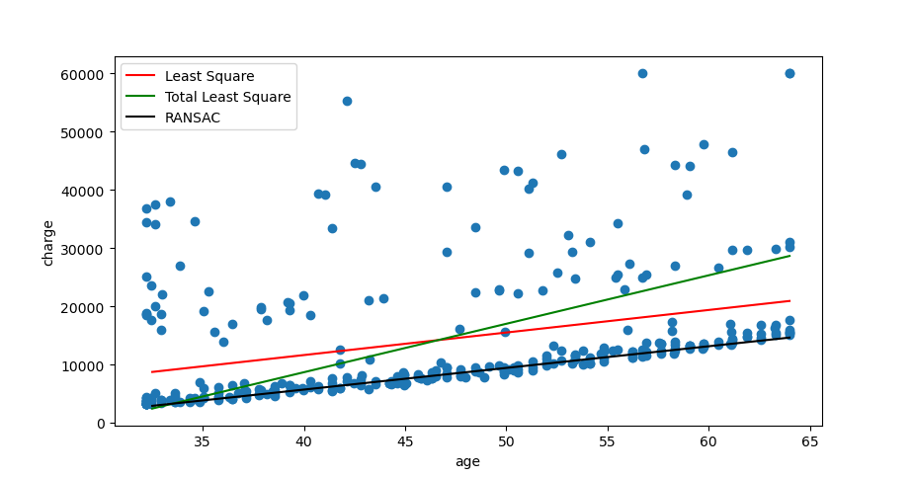

3. Briefly explain all the steps of your solution and discuss which would be a better choice of outlier rejection technique for each case.
Read the csv file to get the age and cost parameters
Stored the age as X matrix and cost as Y matrix
Normalized both the matrices

- Least Square method
- Did append the X matrix with ones such that X = [ 1 X ]
- Used Normal equation to find m, c (from y = mx + c)
- Used np.linspace to create a x list so the corresponding ans using the found parameters can be found.
- Denormalized the x and ans matrix.
- Did plot x and ans in matplotlib.

- Total Least Square method
- Did compute the U matrix (U = [X-X_mean Y-Y_mean])
- Did compute U_transpose*U
- Found the eigenvalues and eigenvectors of the U_transpose*U matrix.
- The found the a, b parameters (ax +by = d) as the eigenvector of the smallest eigenvalue.
- Calculated d as d=aX_mean + bY_mean
- Used np.linspace to create a x list so the corresponding ans using the found parameters can be found.
- Denormalized the x and ans matrix.
- Did plot x and ans in matplotlib.

- RANSAC
- Initialized Minimum number of data points required to estimate model parameters.
- Initialized Maximum number of iterations allowed in the algorithm.
- Initialized Threshold value to determine data points that fit well by model.
- Initialized Number of close data points required to assert that a model fits well to data.
- Initialized an empty Best Fit list to store model parameters which best fit the data (or null if no good model is found)
- Iterated using Maximum number of iterations
- For every iteration, selected random Minimum number of data points in a maybeInliers list required to estimate model parameters from the X and Y coordinates.
- Used Least square method to find the line parameters for the selected points.
- Iterated over the remaining points and stored the points in a alsoInlier list that have an error less than the set threshold.
- Merged the maybeInliers and alsoInliers list
- Found new parameters using the new list and computed the cost for all the points.
- Store the found parameters if the cost found is less than the previous cost.
- Computed eigenvalues and eigenvectors of A*A_transpose and stored it as U.
- Computed eigenvalues and eigenvectors of A_transpose*A and stored it as V.
- Sorted the eigenvalues of A*A_transpose and stored it as lambda.

RANSAC would be a better choice for outlier rejection.

Q4. The concept of homography in Computer Vision is used to understand, explain and study visual perspective, and specifically, the difference in appearance of two plane objects viewed from different points of view. This concept will be taught in more detail in the coming lectures. For now, you just need to know that given 4 corresponding points on the two different planes, the homography between them is computed using the following system of equations Ax = 0, where A is given by

1. Show mathematically how you will compute the Singular Value Decomposition (SVD) for the matrix A. [10]

A*A^{T} matrix
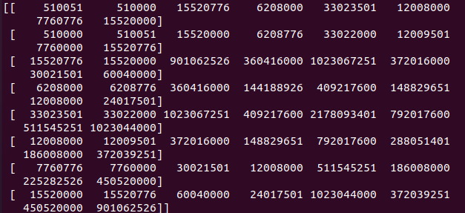

A^{T}A matrix
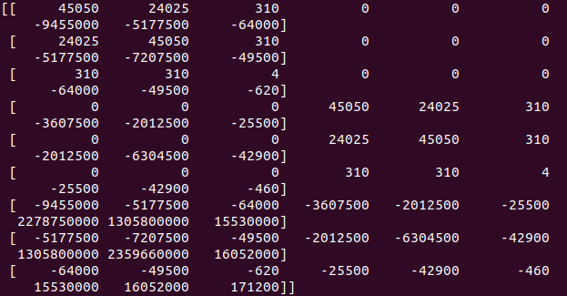
U matr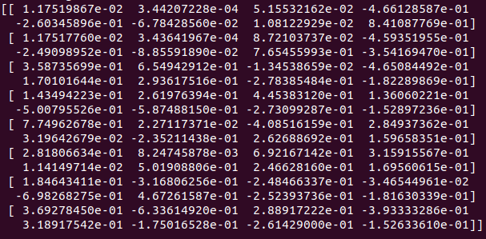

Sigma matrix
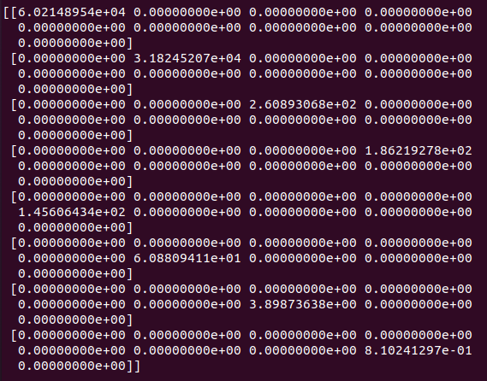

V matrix
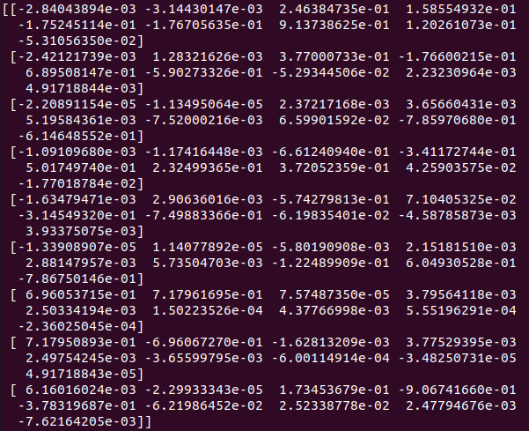

2. Write python code to compute the SVD. [10]
